**REGIONAL BUSINESS CONFERENCE**

**"ECONOMIC PARTNERSHIP AND BUSINESS DEVELOPMENT IN THE PLOVDIV REGION"**

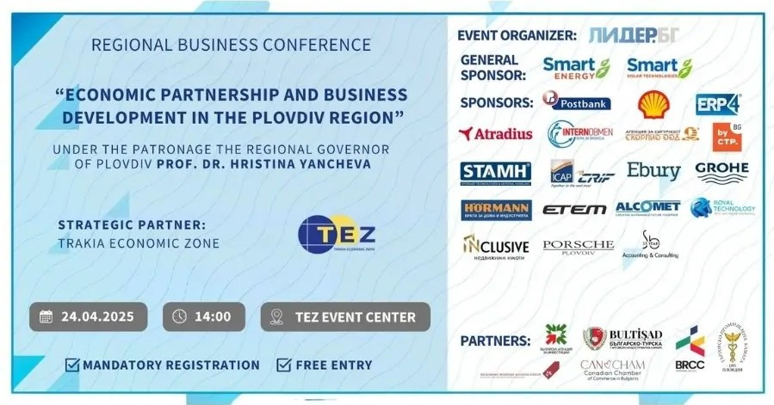

**PROGRAM**

**🕒 14:00 – Opening of the Conference by the Regional Governor of Plovdiv – Prof. Dr. Hristina Yancheva**

* **Welcome Address by Eng. Plamen Panchev** – Founder of Trakia Economic Zone
* **Welcome Address by H.E. Mehmet Sait Uyanık**, Ambassador of the Republic of Türkiye (TBC)
* **Welcome Address by H.E. Brândușa Ioana Predescu**, Ambassador of Romania (TBC)
* **Welcome Address by Ms. Heather Bistrick** – Trade Commissioner at the Embassy of Canada in Bucharest
* **Welcome Address by Mr. Krasimir Yakimov** – Deputy Minister of Innovation and Growth (TBC)
* **Welcome Address by Mr. Fikret İnce -** Chairman of the Supervisory Board of Alcomet AD
* **Welcome Address by Mr. Burhan Nemutlu** – Chairman of the Bulgarian-Turkish Chamber of Commerce and Industry
* **Welcome Address by Mr. Viktor Gugushev** – Chairman of the Bulgarian-Romanian Chamber of Commerce
* **Welcome Address by Ms. Bilyana Georgieva** – CEO of Lider.BG and event organizer

**🕒 14:30 – Part One: Investment Potential of Trakia Economic Zone and Successful Business Practices**

* **Eng. Plamen Panchev** – Long-term Development Strategy of Trakia Economic Zone and Opportunities for Foreign Investors
* **Odelo Bulgaria Representative** – A Successful Case of Turkish Investment in Trakia Economic Zone
* **Schneider Electric Representative** – The Smart Factory of Trakia Economic Zone (TBC)
* **Mila Nenova, CEO of Bulgarian Investment Agency –** Encouraging investments in the region

**🕒 15:00 – Part Two: New Growth Opportunities**

* **Smart Solar –** Svetoslav Mladenov, CEO (**TBC**)
* **CTP** – Svetlozar Dimitrov, Commercial Director
* **Postbank –** Vladimir Dimitrov, Head of Sales Management Unit, BMB Segments & Sales Department
* **Atradius –** Vladimir Vachkov, Country Manager for Bulgaria
* **Ebury –** Svetoslav Georgiev, Commercial Director
* **Stamh –** Vladimir Shokordov, Commercial Director
* **InternObmen –** Nikoleta Ivanova, Commercial Director
* **Grohe – Representative**
* **Security Agency "Scorpio" –** Kamen Penkov, Commercial Director
* **ICAP CRIF Bulgaria –** Dinka Toleva, Senior Sales Consultant
* **Lider.BG –** Bilyana Georgieva, CEO

**🕒 16:30 – Networking Session and Business Expo**

Explore company booths from:  
📌 **ETEM, Hormann Bulgaria, SB Accounting, INCLUSIVE Real Estate Agency**  
🚗 **Special participation by PORSCHE PLOVDIV**

**🕒 19:00 – Conference Closing**